**USING ORACLE**

**QUESTION1)**

CREATE TABLE Customer

(CustNo VARCHAR2(8) CONSTRAINT CustNoNotNull NOT NULL,

CustName VARCHAR2(30) CONSTRAINT CustNameNotNull NOT NULL,

Address VARCHAR2(50) CONSTRAINT AddressNotNull NOT NULL,

Internal CHAR(1) CONSTRAINT InternalNotNull NOT NULL,

Contact VARCHAR2(35) CONSTRAINT ContractNotNull NOT NULL,

Phone VARCHAR2(11) CONSTRAINT CPhoneNotNull NOT NULL,

City VARCHAR2(30) CONSTRAINT CityNotNull NOT NULL,

State VARCHAR2(2) CONSTRAINT StateNotNull NOT NULL,

Zip VARCHAR2(10) CONSTRAINT zipNotNull NOT NULL,

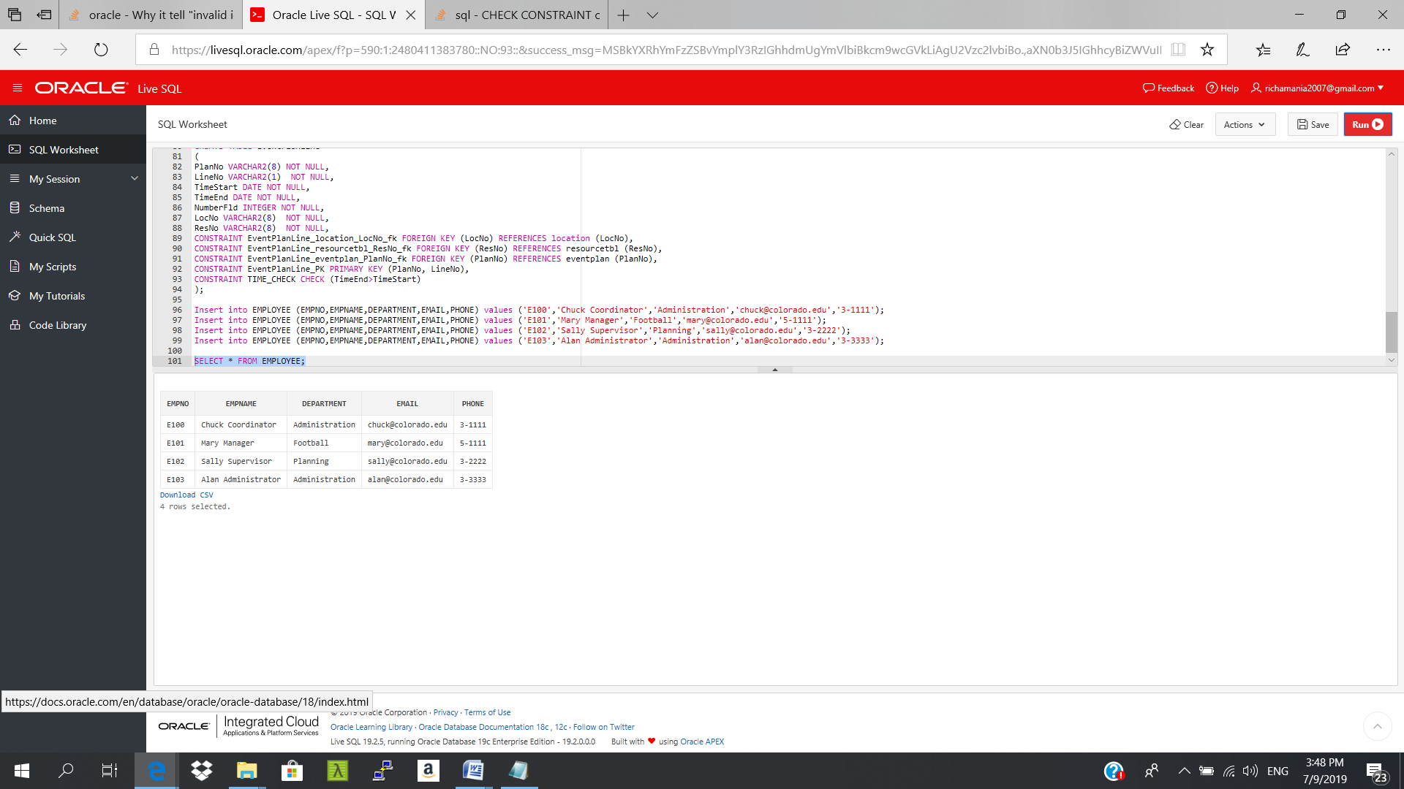 CONSTRAINT PK_CUSTOMER PRIMARY KEY (CustNo) ) ;